1.Inverted right-angle triangle
#include<iostream>
using namespace std;

int main()
{
int n;

cin >> n;

for(int i=1; i<=n; i++)
{
for(int j=1; j<=i; j++)
{
cout << "* ";
}
cout << endl;
}

return 0;
}
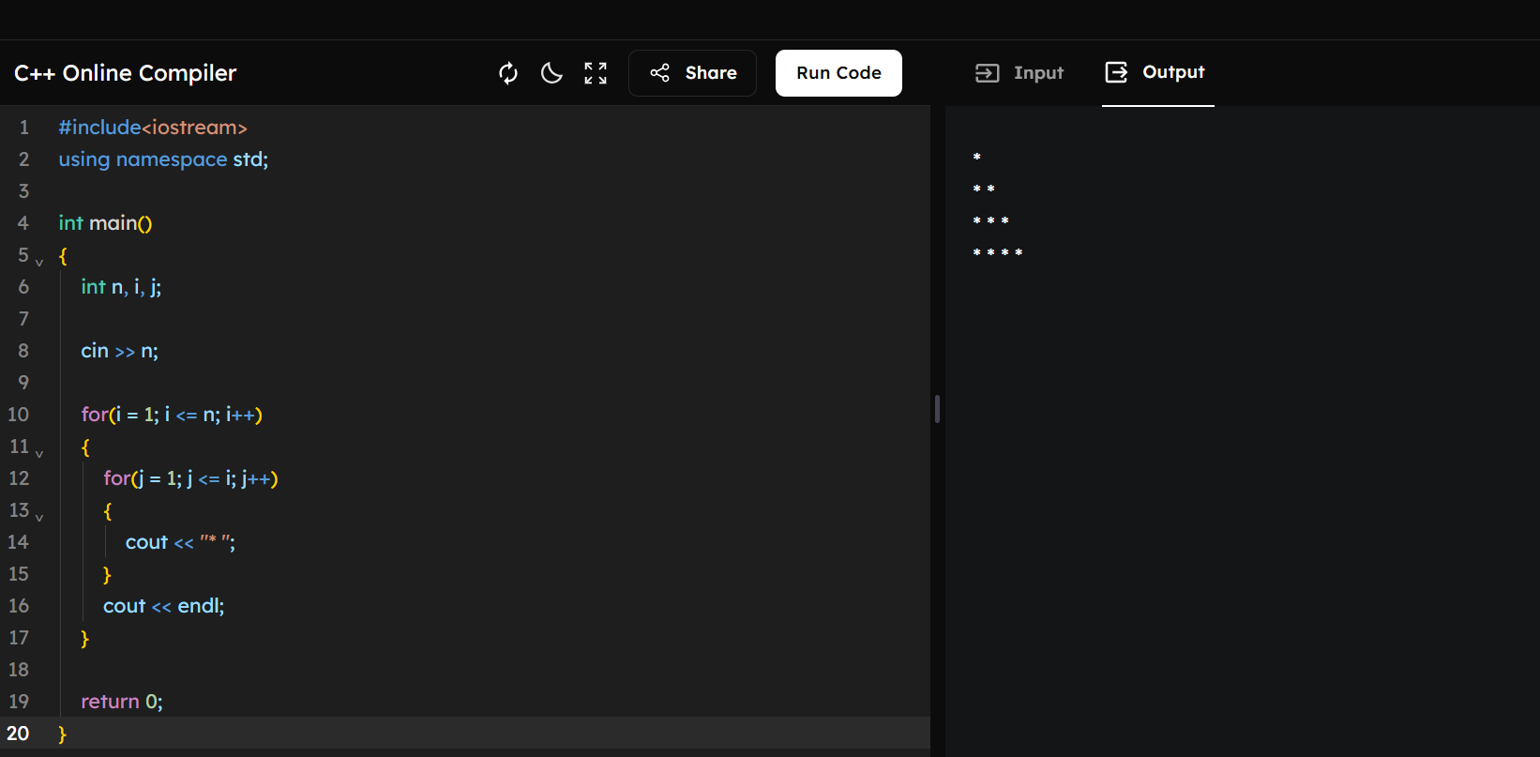

2.Strong number
#include<iostream>
using namespace std;

int main()
{
int n, temp, rem, fact, sum=0;

cin >> n;
temp = n;

while(temp > 0)
{
rem = temp % 10;
fact = 1;

for(int i=1; i<=rem; i++)
{
fact = fact * i;
}

sum = sum + fact;
temp = temp / 10;
}

if(sum == n)
cout << "Strong Number";
else
cout << "Not Strong Number";

return 0;
}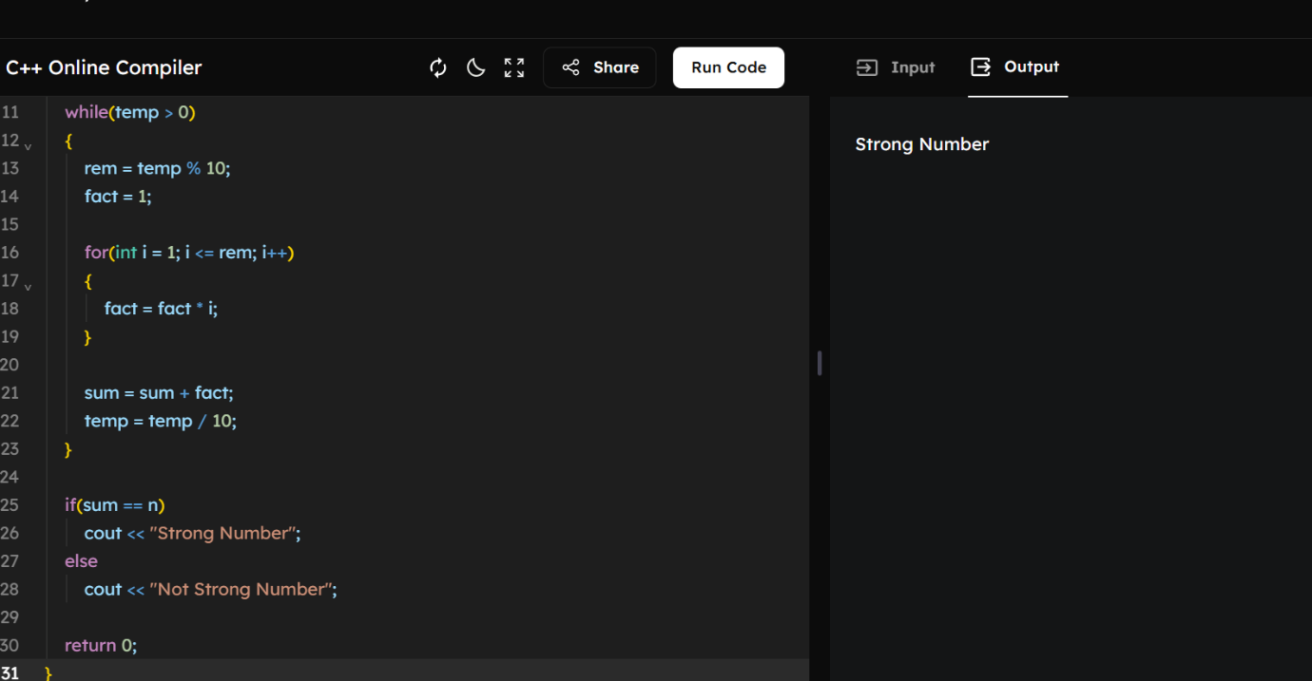
3.Count the frequency
#include<iostream>
using namespace std;

int main()
{
int n, digit;
int count[10] = {0};

cin >> n;

while(n > 0)
{
digit = n % 10;
count[digit]++;
n = n / 10;
}

for(int i=0; i<=9; i++)
{
if(count[i] != 0)
{
cout << i << " = " << count[i] << endl;
}
}

return 0;
}
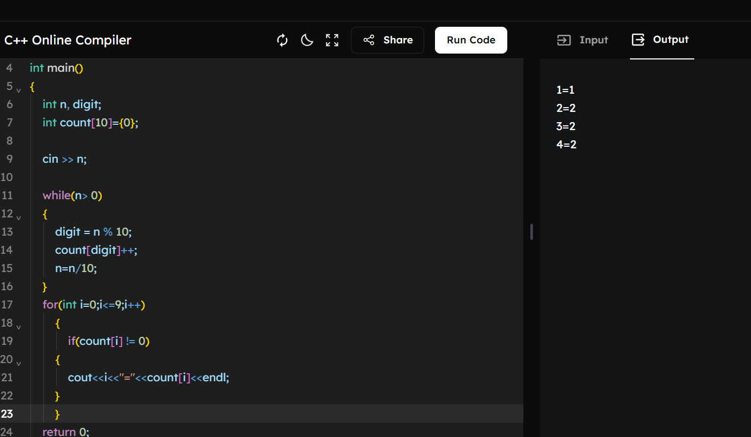
4. Count the number of divisors of a number.
#include<iostream>
using namespace std;

int main()
{
int n, count = 0;

cin >> n;

for(int i=1; i<=n; i++)
{
if(n % i == 0)
{
count++;
}
}

cout << count;

return 0;
}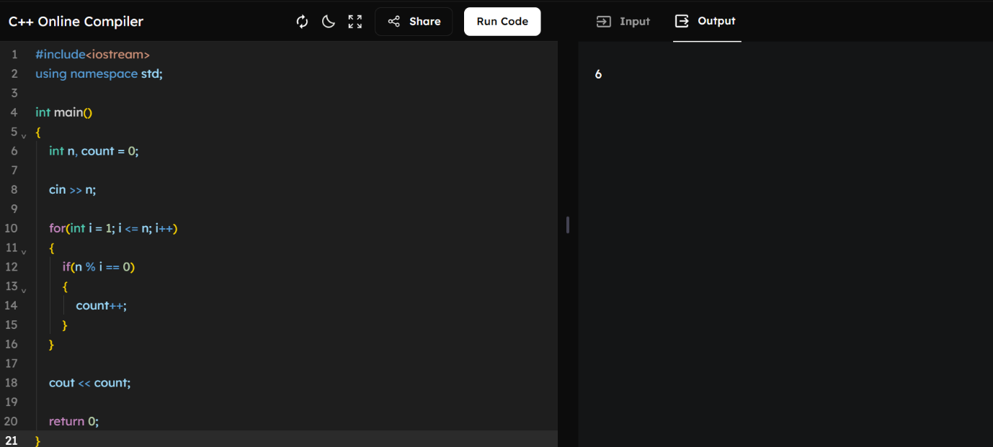
5.Compound Interest
#include<iostream>
#include<cmath>
using namespace std;

int main()
{
float p, r, t, amount, ci;

cin >> p >> r >> t;

amount = p * pow((1 + r/100), t);
ci = amount - p;

cout << ci;

return 0;
}
